Harlan tourism

presents:

Fun, FIlled, 4th of July Parade
Thursday July 4th 2024
Parade lineup starts at the
Harlan Baptist Church at 3:00 PM.
Parade begins at 4:00 pm
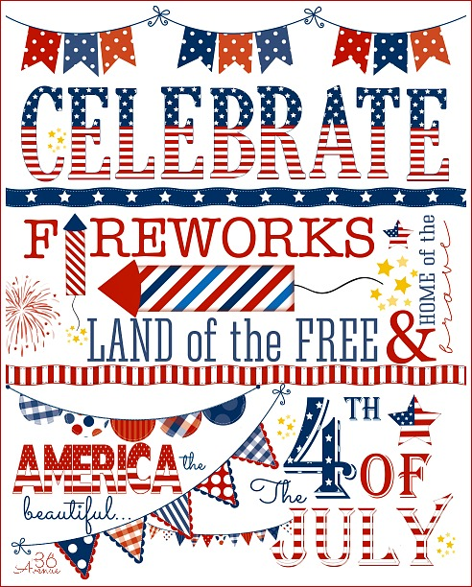

Sponsored by the harlan tourist & Convention commission

Fun, Filled, 4th of July Parade APPLICATION FORM
EACH ENTRY MUST HAVE A PROPERLY COMPLETED APPLICATION FORM. Deadline for applications is Monday, June 28, 2024. Applications must be mailed to the Harlan Tourist & Convention Commission- PO Box 489 Harlan KY 40831 or dropped off at the Harlan Center from 9am-5pm Monday thru Friday on or before the
deadline date. NO APPLICATIONS WILL BE TAKEN OVER THE PHONE. Applications may be picked up at the Harlan Center.
Name of Company/Organization:
Contact Person:
Address:
Phone Number (Mandatory):
Email Address:
License # of Vehicle in Parade (Mandatory):

Please Check Appropriate Items: ___ Float
___ Civic Group
___ Organization
___ Other
Please give a brief description of your entry:
The following rules apply:
- Drivers must have a valid license and proof of insurance with them.
- Proof of insurance must be submitted with application.
- Children must be accompanied by an adult; one adult per 7 children.
- No throwing items from the float/vehicle; no candy, trinkets, etc.
- Organization’s name must be displayed on both sides of truck/float.
- Walking groups must be in costume, identified and supervised.
- Independence Day decorations required on all vehicles.
- ATV clubs with insurance are invited to participate in parade.
- No one may get on or off float during parade.
- Participants must remain in parade for its entirety.
- Parade lineup begins at Harlan Baptist Church. All vehicles must enter through the checkpoint at the Coal Monument in Baxter.
- No alcoholic beverages.
- Incomplete applications will be rejected.
PARADE OFFICIALS RESERVE THE RIGHT TO REMOVE ANYONE AT ANY TIME IF THEY ARE NOT IN COMPLIANCE WITH PARADE RULES.

Awards will be given in the following categories:
- Best Children’s Float *Holiday Hero *Most Patriotic *Best 4th Of July Themed Entry *Harlan Tourism Award *Best Scouting Group *Vintage Vehicle *Grand Prize
All floats will be stopping momentarily at the Harlan Center before the Judge’s Table.

I hereby certify that I have read the rules and regulations and agree to abide by them. I understand that the City of Harlan, and the Harlan Tourism Commission are not responsible for theft, damage or injury, and I have read, accept, and will follow the regulations governing this event.
SIGNATURE: DATE:
PRINT NAME:

